New Bob T/A and T/B Button for Order Handling on TE

Overview

Current processing
An order that is sent with T/A button from PAR does not trade with Auto Quote.

New requirement
- If CBOE is NBBO, incoming order sent by T/A button from PAR will trade against the Book, in the order of Customer, Non-customer, Manual Quote Liked orders and start SAL before trades with Auto Quote. The remainder will be sent back to PAR.

- If CBOE is not NBBO incoming order sent by T/A button from PAR is returned to the Sender immediately.

- If CBOE is NBBO, incoming order sent by T/B button from PAR, it only trades against the Customer orders in the Book if the Customer order, Manual Quote order and Auto quote are at the top of the book. The remainder will be returned to PAR.

- If CBOE is not NBBO, incoming order sent by T/B button from PAR will not traded with any Customer orders in the Book and be returned back to PAR immediately.

Assumption
- T/A and T/B Order must not be linked away.

Implementation
Modify the BrokerStrategyFactory to find the right new Strategy classes below. The following are list of Classes needed they will extend BrokerLimitOrderStrategy:

- BrokerNewBOBOrderForTBStrategy (New)
- BrokerNewBOBOrderForTAStrategy (New)

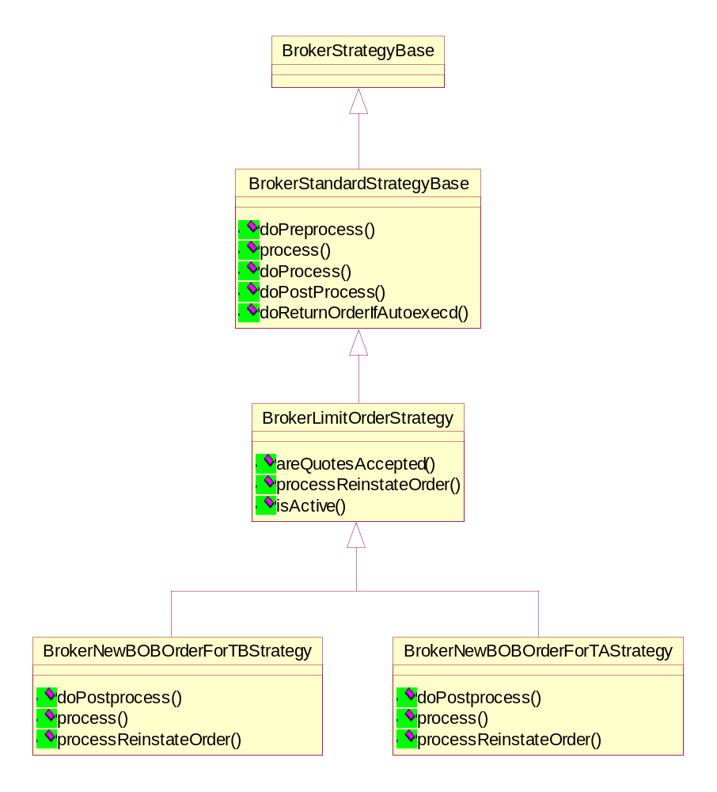

Simple Order processing path for IOC and ISO:

- OrderRoutingDestinationImpl will receive the request through acceptOrder().
- the Order will be processed further using BrokerServiceImpl, BrokerImpl using the Product or Class level (lock) Command Queue.
- Further AcceptOrderCommand and will use BrokerProcessorHybridImpl to processOrder(). Actual processing of Order will be done using the appropriate strategy that can be found using BrokerStrategyFactory depending upon the type of contingency (IOC or ISO).

        - IOC Contingency: This type of contingency will use BrokerNewBobIOCOrderStrategy to do the processing by calling method process() and the post processing using method doPostProcess() after attempting the Trade, any quantity remaining will be cancelled using Order.cancel().

        - ISO Contingency: This type of contingency will use BrokerNewBobISOOrderStrategy to do the processing by calling the method process() and the post processing using method doPostProcess() after attempting the Trade (NBBO protection will be ignored while trading) any quantity remaining will be cancelled using Order.cancel().

Sequence Diagrams
The implementation on both IOC and ISO will take new path without aggregating the old Bob class processing path. The following sequence Diagrams are for both Old Bob and New Bob class:

Old Bob IOC Order Path

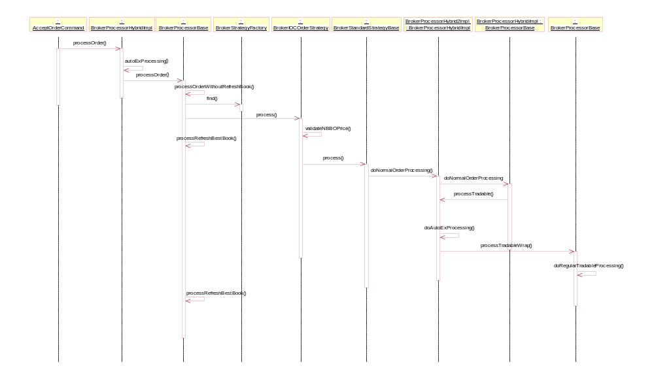

New Bob IOC Order Path

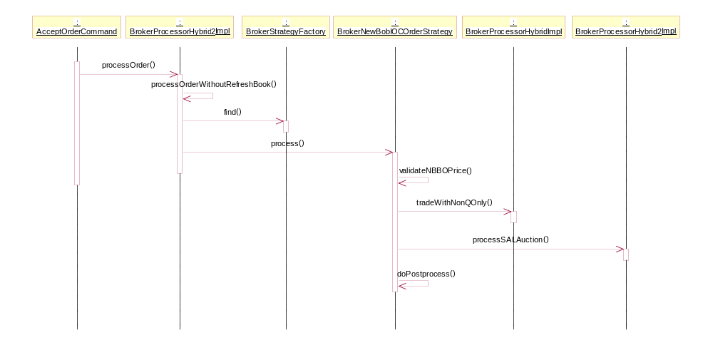

New Bob ISO Order Path:

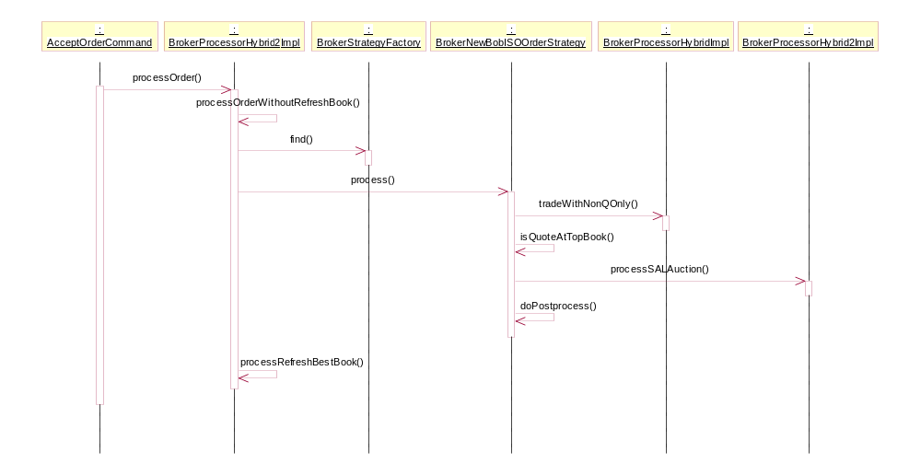

Scripts
- None

Database
- None

SetContext

XML/DTD

Homes/Services
- None

PerformanceTestingProcedure
- .

TestingProcedure

OperatorProcedure
- .

Fallback/Failover

